**G.O.A.L.S. HONOR SYSTEM**

* We will take pride in our academic performance, as well as our behavior.
* We will respect others as we wish to be respected.
* We will hold each other and ourselves to a high standard of conduct.
* We will strive to gain trust of the people around us by being trustworthy.
* We will fully accept responsibility for our actions, without complaints, regardless of the consequences.
* Our personal honor towards ourselves and others is the foundation of the G.O.A.L.S. system.

(Created by the G.O.A.L.S. students)

**G.O.A.L.S**

G- Goal-Setting

O- Occupational Opportunities

A- Academics

L- Living Independently

S- Self-Awareness

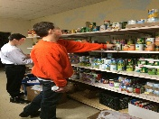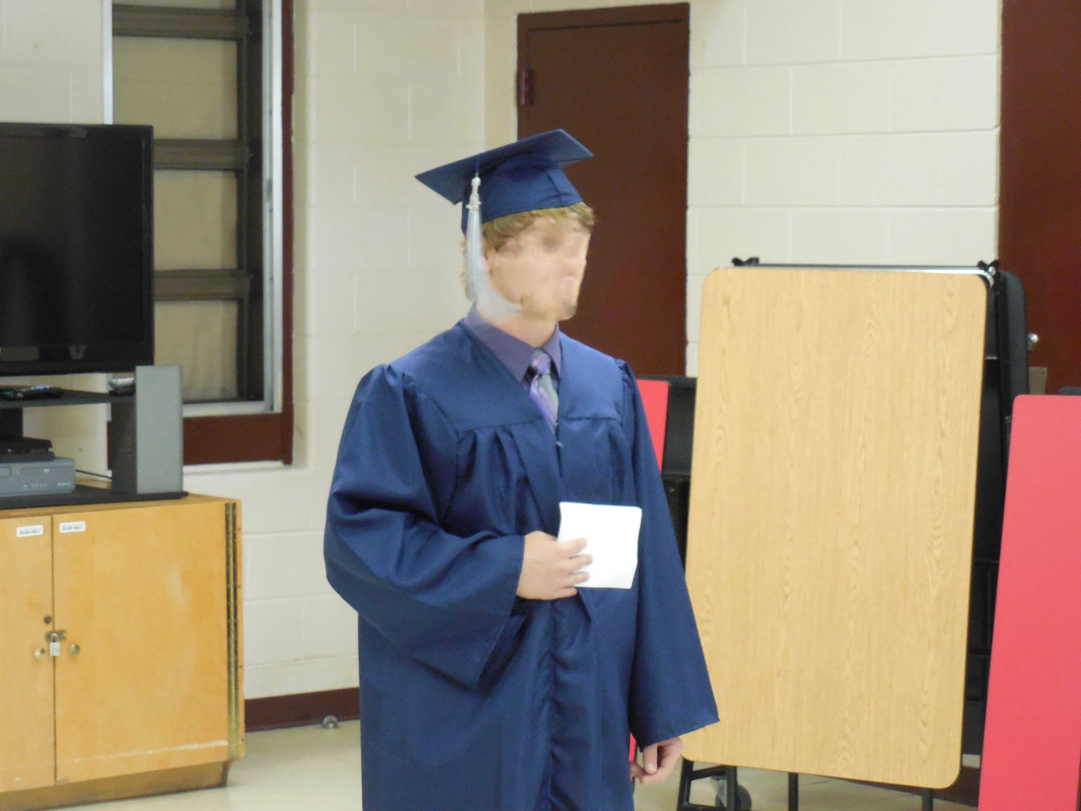

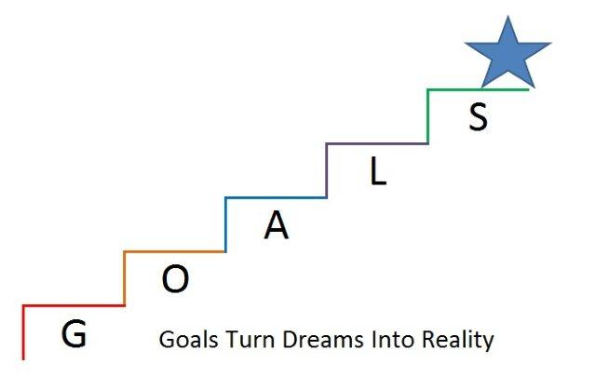



Post-Dispositional Program

of the

New River Valley

650 Wades Lane, Christiansburg, VA 24073

Phone: 540-381-0097

Fax: 540-382-1667

www.nrvjdh.org

Post-Dispositional Program Summary

The student is deemed eligible for participation in the PD program according to COV §16.1-284.1.

* Placement is for 31 to 180 days (as determined by the court).
* A Service Plan is created with input from court services, parents/guardians, PD Coordinator, education department, and mental health workers.
* Monthly progress reviews are held.
* Career assessments are given.
* Other assessments determine personal resources and barriers to employment.
* Educational and career goals are clarified.
* Available resources are matched with student goals.
* Career and educational goals are narrowed and researched.
* Job readiness skills are emphasized.
* A plan of action is developed for school and community re-entry.
* Short-term and long-term goals are determined and a written follow-up plan is created.
* Implementation of program objectives are determined by the capabilities of the facility.

Facility Mental Health Opportunities

* Individual Treatment Plans.
* Individual counseling sessions.
* Anger Management groups.
* Substance Abuse groups.
* Summer programming focusing on being mentally healthy.

G.O.A.L.S.

*Goals Turn Dreams Into Reality*

Program Goals

Students will explore educational and vocational opportunities, as well as focus on personal growth issues. A Service Plan, in conjunction with the state designed PD curriculum, will guide the instruction and experiences in career exploration, independent living skills, and pre-employment and employment strategies. The students will complete the program with established, attainable goals and a process for implementing them. The goal is to provide the participants with the proper resources to prevent their return to the juvenile justice system.

The Students

The Post-Dispositional Program of the New River Valley serves students who are 14-17 years of age and are determined by the courts to benefit from the program. They are then enrolled or “posted” 31 to 180 days. If a student does not comply with the terms of the Service Plan, any suspended commitments may be re-instated.

Community Involvement

The G.O.A.L.S. Program stresses the importance of helping others and being a productive citizen in your community.

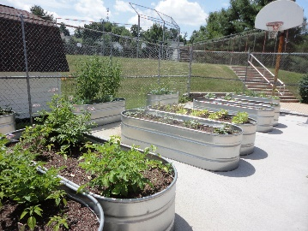

G.O.A.L.S. participants volunteer in the community through growing, harvesting, and donating vegetables; and preparing and donating floral arrangements and small plants. The participants also contribute to the beautification of the facility grounds.

Teachers Provided by Montgomery County School Board

Post-Dispositional Classes

*Academic classes* are provided to meet educational goals and to continue GED or home based school objectives. For classes that the facility is not equipped to teach, alternative courses may be taught with the approval of the student’s home school.

*Pre-employment classes* expose students to a wide variety of careers. They create resumes and learn job seeking skills. Guest speakers such as military recruiters and college representatives may also visit with classes.

*Independent living* provides students with instruction in basic skills for daily life. Skills may range from balancing a checkbook, to cooking, to childcare and beyond.

*Employment classes* provide assessments of individual interests and abilities. Students receive basic computer technology training. Activities are geared toward gaining and maintaining employment.

*Art activities* allow for exploration of leisure time activities, hobbies, and recreation.

*Physical Education* provides for the health and fitness requirements of adolescents.

*Health classes* are taught to encourage informed decision making on health issues and disease.

New River Valley Juvenile Detention Home

The New River Valley Juvenile Detention Home primarily serves the 27th Judicial District which includes the owner jurisdictions of Montgomery, Pulaski, Radford City, and Giles. The G.O.A.L.S. Program accepts only court-ordered placements. The facility opened in 1974 and is under the direction of Mr. Joseph W. Young, Jr.

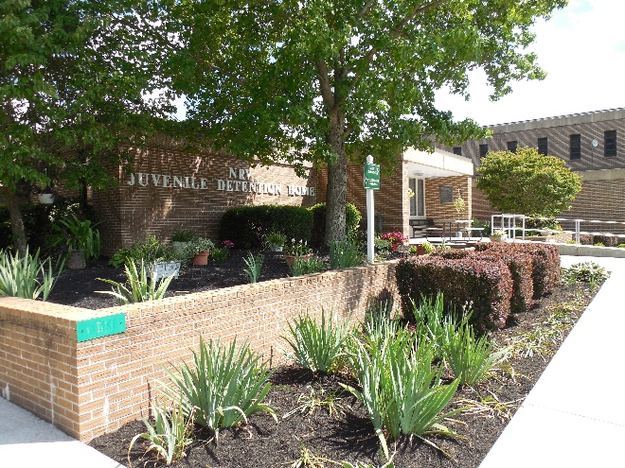

Purpose and Philosophy

The philosophy of the G.O.A.L.S. Program is twofold. First, it is to provide court services and judges an alternative to state placement for those juveniles that are deemed appropriate for intervention through a prescriptive and rehabilitative education model in reference to VA Code 16.1-284.1.

Secondly, juveniles will leave the program in a better mental and physical condition than they exhibited upon entering and more able to live appropriately in society.