

A Teen’s Guide to Reporting Physical and Sexual Abuse, Neglect and Sexual Harassment in Juvenile Detention

**Frequently Asked Questions**

* **I f I report abuse, will anyone believe me?**

Yes. If you report abuse, you will be believed and your case will be fully investigated to uncover evidence that proves what happened.

* **Will the person who abused me be allowed to have contact with me?**

No. After a report of abuse is made, the person whoabused you is removed from contact with you during the facility’s investigation. This does not mean that you will necessarily be released from the facility or moved to another facility, but you will be protected.

* **Will the facility punish me or treat me different (retaliate) i f I report abuse?**

No. If you make a report of abuse and have told the truth, you will not be punished, treated differently or receive any discipline. You will be protected from further harm and the case will be investigated. If you are retaliated against, report it to a trustworthy staff member immediately and it will be investigated.

* **Will I have to testify in court?**

The facility and outside investigators will ask you questions about what happened. If the abuser faces criminal charges, then you may be asked to testify in court.

* **Will reporting affect my juvenile court case, my detention or placement status?**

No. Making a report of abuse will not extend your stay in detention, lengthen your probation term or change your current placement status, but you may change facilities.

* **What if I lie about being abused?**

All reports of abuse are taken very seriously and investigated thoroughly. Anyone who makes a false report will be charged with a serious criminal offense.

Remember, reporting abuse is not a game and you should always tell the truth.

* **What i f the abuse happened at home?**

If the abuse happened at home, at school or in your community, then you should report it to a staff member you trust.

**A publication by the:**

**New River Valley Juvenile Detention Home**

**650 Wades Lane**

**Christiansburg, VA 24073**

**540-381-0097**

**www.nrvjdh.org**

**Summer 2013**

[Future Solutions Now]

**If Abuse Happens to You…**

**Break The**

**Silence**

**Abuse is a crime…**

**Tell someone now!**

**What Else Can I Do?**

There is a phone number you can call to report abuse if you do not feel comfortable filing a grievance or talking to someone in the facility. Your report will be investigated whether you report it to facility staff or if you call directly.

The phone number to report abuse is:

**540-961-8350**

Your call will be given prompt attention by the appropriate person. When you call, you do not have to give your name (unless it is necessary to conduct the investigation), and if you do, your name and your identity will be protected and kept confidential (secret).

**No one should be abused.**

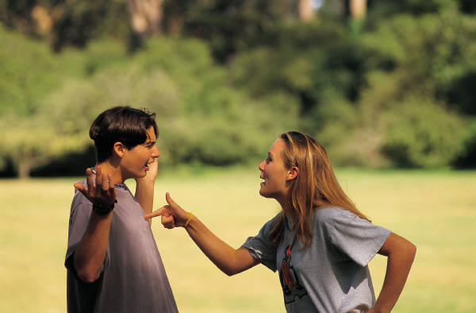

No Means No and   
Yes Is Not Allowed.

**Break The Silence…**

**Tell a Friend. Tell Staff. Tell Someone You Trust.**

**What is physical abuse?**

Physical abuse is something done to you that causes physical pain or injury to your body, often called an assault. It may involve hitting, kicking, punching, choking, shoving or other act done by an adult or another resident against you.

**What is sexual abuse?**

Sexual abuse is a sexual act committed against you or the intentional touching of your body in a sexual way by another detainee or staff. Sexual abuse happens when someone asks you to flash or expose the private areas of your body or asks you to engage in sexual intercourse or other sexual behaviors.

**What is sexual harassment?**

Sexual harassment is the repeated and unwelcome sexual advances, requests for sexual favors, or verbal comments, gestures, or actions of a derogatory or offensive sexual nature by one detainee directed toward another; and repeated verbal comments or gestures of a sexual nature to a detainee by a staff member, contractor, or volunteer, including demeaning references to gender, sexually suggestive or derogatory comments about body or clothing, or obscene language or gestures.

**Can Abuse Happen to Me?**

In a juvenile justice facility, you have the right to be safe and protected against abuse. Abuse includes physical and sexual abuse, and sexual harassment. We make every effort to keep you safe from harm. Despite the best protections in place abuse might sometimes happen. It is important that you know what to do if it happens to you or someone else.

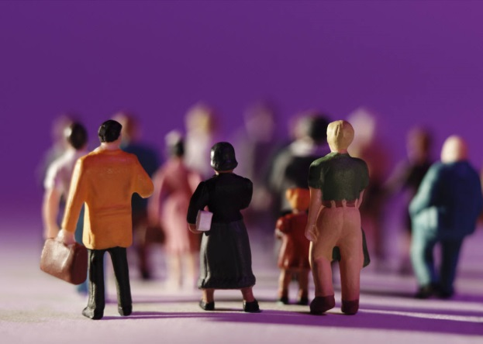

**Trustworthy Adults**

In the facility, there are many adults who you see every day that will help you and protect you. If you feel comfortable, you should talk to a facility staff member, counselor, teacher or medical professional and tell them if you have been abused. There are also many adults who may visit you in the facility that can also listen and help such as your attorney, your probation officer, your parent, guardian or other family member.

**Facility Grievance System**

Each juvenile justice facility has a way to handle your complaints or problems, sometimes called “grievances” and this is called a Grievance System. The facility grievance system is a choice that is always available for you if you do not feel comfortable talking to a staff member directly.

You can even use our Grievance drop box if you do not want to give a written grievance to a staff member. If you use the drop box just remember we only check this box through the week (not on weekends) so if your complaint is urgent, do not use this method.

**Abuse is a crime…**

**No matter where you live.**

**What if I see or hear about someone else being abused?**

If you see another resident being abused or you hear about someone else being abused, you should report this. All abuse is wrong and everyone deserves to be protected at all times in a facility. You can help others by reporting abuse.

**What if the abuser is another juvenile?**

Other residents in the facility may commit abuse against you. This may involve physical and sexual assaults. Abuse by other juveniles should also be reported. You have a right to be protected at all times from other juveniles in the facility.



We Have Zero Tolerance for Sexual Abuse and Harassment

**Who Can Commit Abuse?**

It is not easy to know what an abuser looks like. Abusers can be someone you know, a friend, relative or a stranger. Any person in a facility may commit abuse. Abusers are not always detention or corrections officers or facility staff members. They can be visitors, volunteers, probation officers, medical personnel, counselors, teachers or other persons in the facility that you meet. Abuse committed by any person against you is wrong and should be reported immediately. No one deserves to be abused and abuse is always a crime…period.

**Victim Advocate**WRC of the New River Valley

1217 Grove Ave

Radford, VA 24143

Business: 540-639-9592

Hotline: 800-788-1123

**National Sexual Assault Hotline**

800-656-4673

**Who Can Help?**

If you are the victim of abuse, there are many people who want to help you. The important thing is to tell someone about the abuse, neglect or exploitation immediately. Do not be silent.